Validation for Caffeine Investigation 2012

Name=______________________________________________

1. An investigation was done to find if the flexibility in the lower back and legs is different between people younger than 20 years of age, compared to people over 40 years of age. The people being tested were asked to sit on the floor and reach forward. The distance that the people could reach past their toes was measured.
2. For this investigation what is the independent variable?( 1mark)
3. What is the dependent variable? (1 mark)
4. State a hypothesis for this investigation. ( 2 marks)
5. Here are the results of this investigation.

Complete the table below

|  |  |  |
| --- | --- | --- |
| Name | Age  (years) | Flexibility  (cm) |
| John | 19 | 10 |
| Jim | 17 | 2 |
| Jenny | 18 | 7 |
| Jack | 18 | 12 |
| Annie | 19 | 9 |
| Total | |  |
| Average | |  |
| Craig | 41 | 0 |
| Sandy | 44 | 2 |
| Lam | 43 | 14 |
| Jasper | 41 | 4 |
| Roddy | 47 | 4 |
| Total | |  |
| Average | |  |

(1 Mark)

1. Draw a suitable graph of the results in the previous table.
2. marks)
3. How could the results have been made more accurate? (1 mark)
4. What is your conclusion for the experiment above?

(1 mark)

1. Using the graph you drew, would it be possible to do accurate extrapolation for people of other age groups? Explain why.

(2 marks)

1. Use this graph to answer the questions that follow

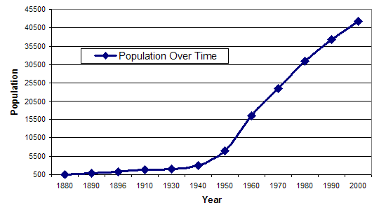

1. What will the population be in 2010?

(1 mark)

1. Was your answer to question 3a an example of extrapolation or interpolation? Give a reason for your choice.

(2 marks)

1. What was the population in 1965?

(1 marks)

1. Was your answer to question 3c an example of extrapolation or interpolation? Give a reason for your choice.

(2 marks)

1. Which was more likely to be correct, your answer to question 3a or 3c? Give a reason for your answer.

(2 marks)

/22 marks